DR.AMBEDKAR COLLEGE, DEEKSHABHOOMI, NAGPUR
DEPARTMENT OF LAW
ACADEMIC SESSION 2023-24

NAME OF THE PROGRAMME: Workshop on Drafting and Pleading
DATE AND DAY: 20th January 2024- Saturday
TIME: 11.30 AM to 3.00 PM
VENUE: Seminar Hall, Department of Law,
PROGRAMME SUPERVISOR: Dr. Pratima Lokhande
PROGRAMME CO-COORDINATORS: Dr.Vaishali A. Sukhdeve and Ms. Sarika Kamdi

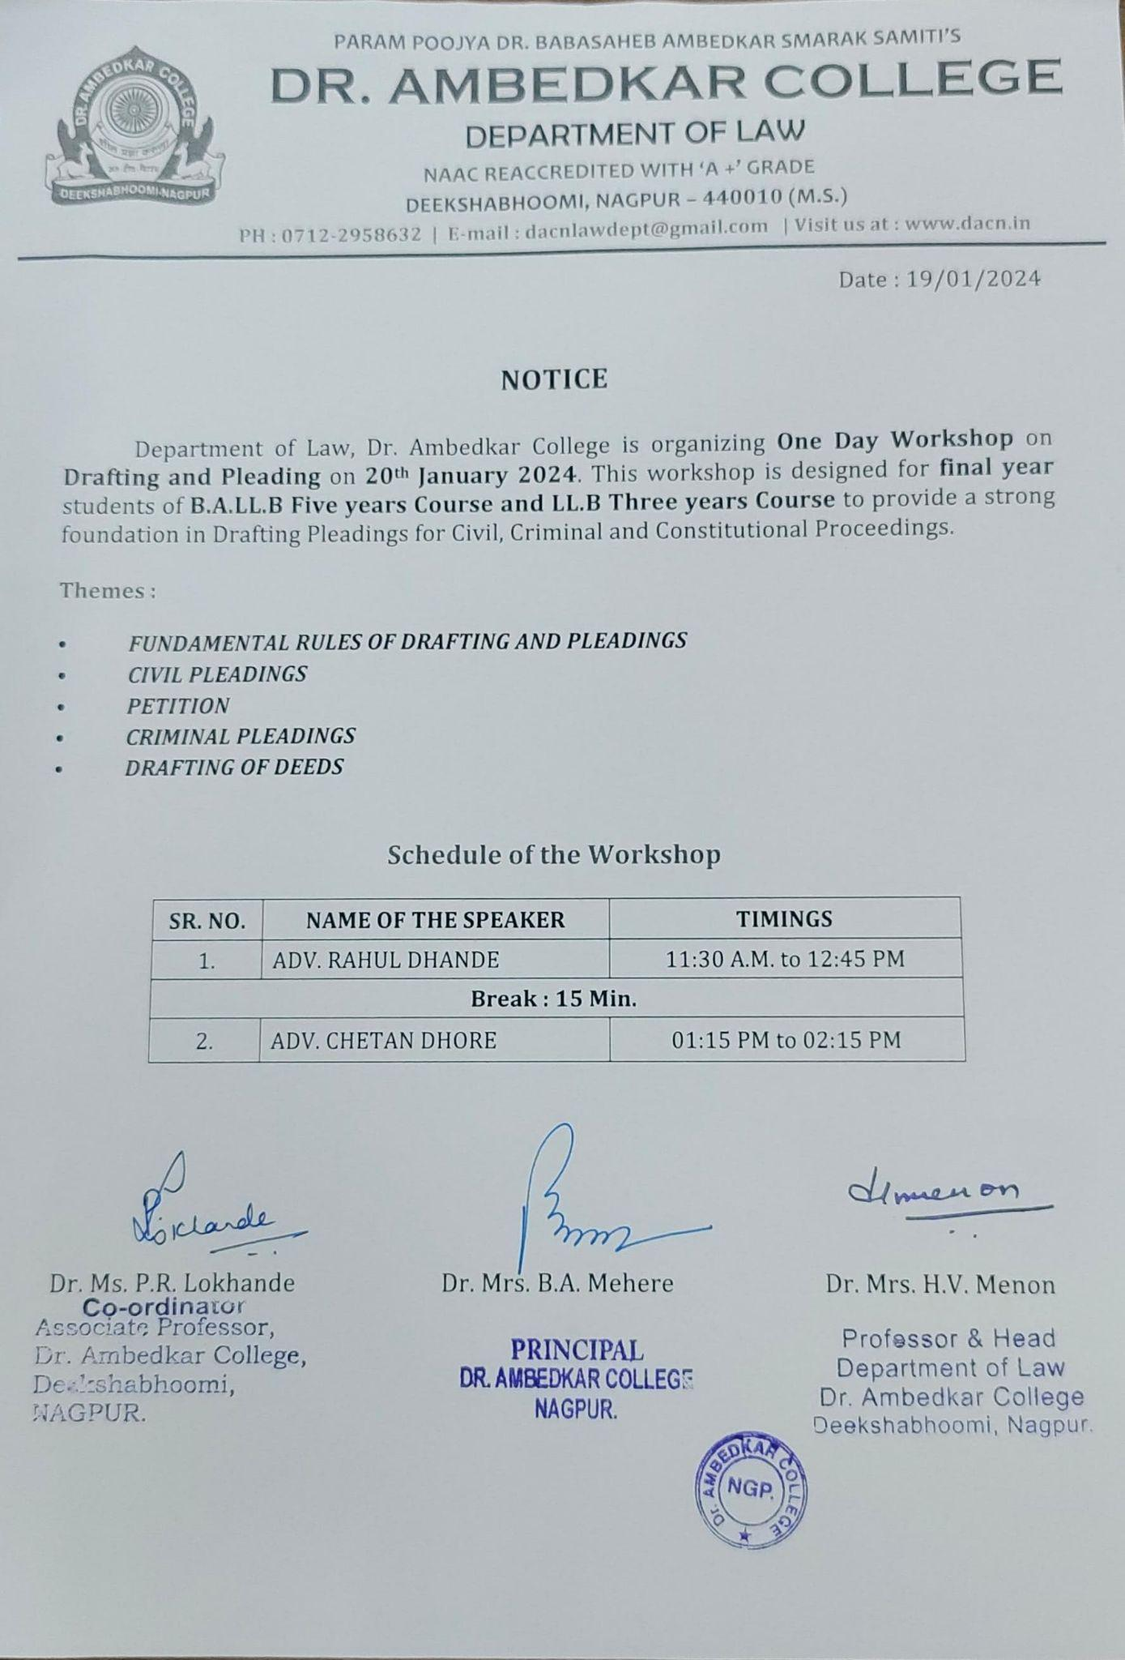
Department of Law, Dr. Ambedkar College had organized a one-day workshop on drafting and pleading for the Final year students of LLB 5 years and 3 years. The objective of the workshop is to provide a strong foundation in the drafting, pleadings for Civil, Criminal and Constitutional matters. About 100 students attended the workshop which was divided into two sessions. The workshop was initiated by paying obeisances to Lord Gatam Buddha and Dr. B.R. Ambedkar which was followed by Introductory remark by Prof. Dr. H.V. Menon, Head of the Department of Law. Prof. Dr. H.V.Menon threw light on the importance of clinical papers for the law students and encouraged them to gain thorough knowledge with respect to niceties of drafting and pleadings through this workshop. The first session was presided over by Adv. Rahul Dhande and the other session was conducted by Adv. Chetan Dhore.
In the first session, Adv. Rahul Dhande, practicing Advocate at Bombay High Court, guided the students on the intricacies of Civil drafting where he gave introduction on how to prepare a plaint and written statement under CPC 1908. He further discussed the essentials of pleading by citing various examples and relevant provisions under the Civil Procedure Code, 1908. He explained how to write a complaint for the recovery of money in the Civil Court and thrown light on the different kinds of jurisdictions of Civil Court. Lastly he motivated students about practice in High courts and steered them about filing a Writ Petition at the High Court.

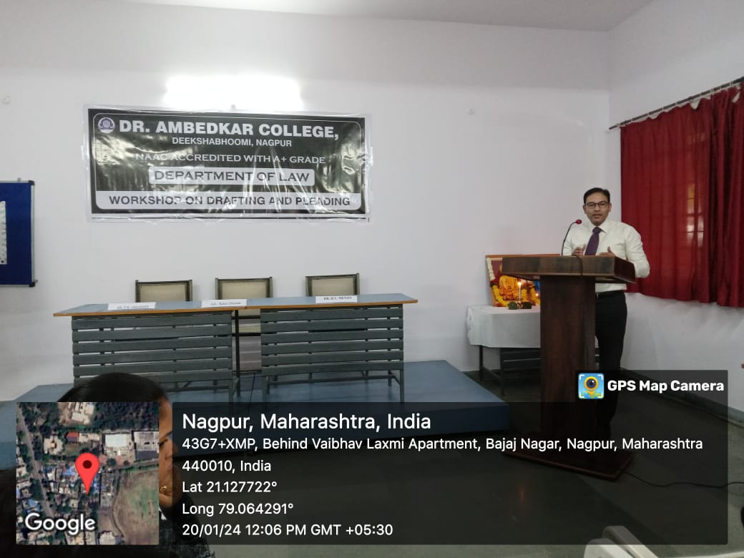
Adv. Rahul Dhande discussing about civil drafting and pleadings with the students

In the second session, Adv. Chetan Dhore, Alumni of the Department and the practicing Advocate at Bombay High Court, Nagpur Bench deliberated the students about writing a plaint and criminal complaint in court of law. He explained the students’ key parts of FIR and further discussed how to quash FIR before a High Court before trial under Section 482 of the CRPC. He elucidated to students by sharing numerous situations and citing live examples of minutiae involved under criminal law. He then shifted his topic on how to write a Writ Petition and what it entails under the Indian Constitution before the High Court and Supreme Court.
Both the speakers of the workshop generously invited students to visit their chambers at Bombay High Court, Nagpur Bench for additional acquaintance about the drafting and pleadings in civil and criminal matters. The workshop was conducted by Divya Toksia, under guidance of Dr. Pratima Lokhande, In charge of Practical subjects.
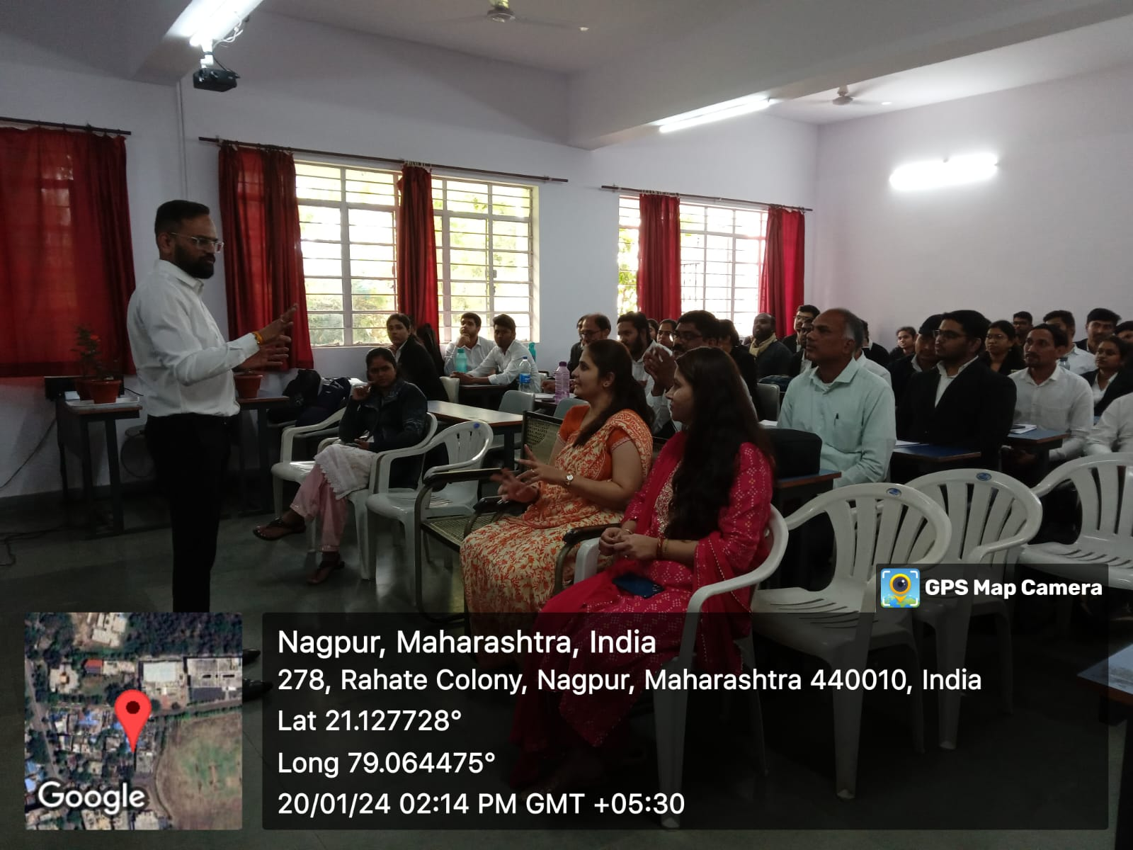
Adv. Chetan Dhore interacting with the students and faculties.

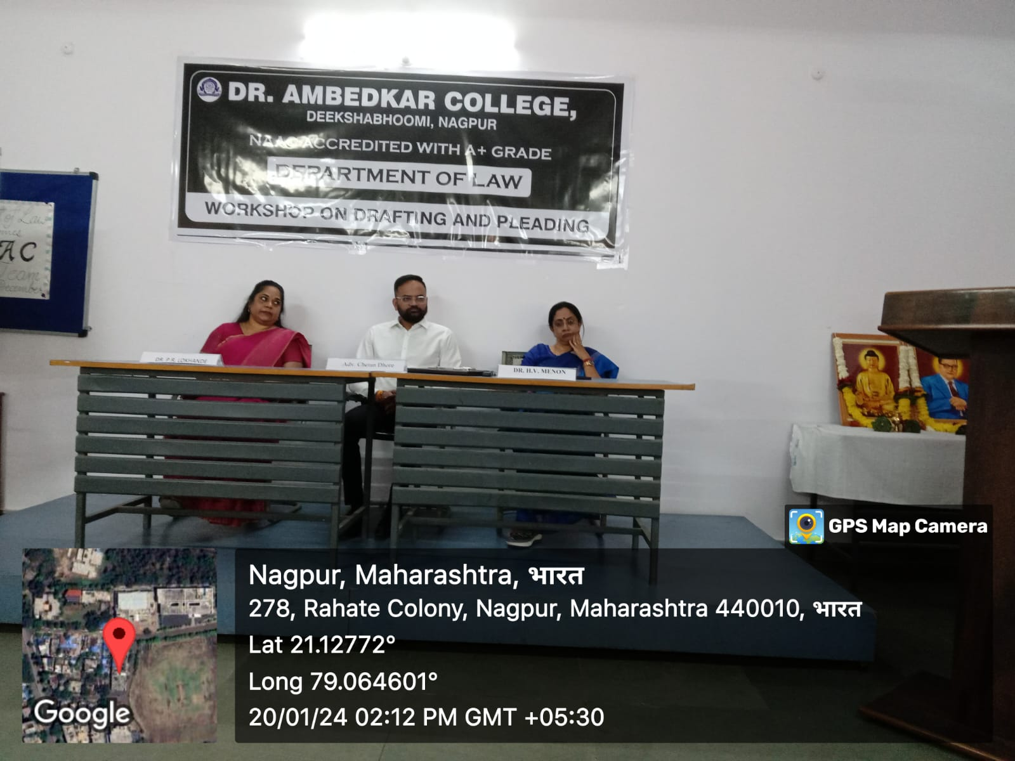
Dr. H.V. Menon, HOD, Dr. Pratima Lokhande and Adv. Chetan Dhore on the dias

